1. In the last lecture, we learnt about “**Template Reference Variable”**. The usages of “**Template Reference Variable”** are as follows
   1. To pass tag reference to Event handler.
   2. To use template reference variable somewhere else but in the same template.  
      **Example**:  
       <p>{{templateReferenceVariable.value}}</p>
2. But, there is one more place where template reference variable can be received. That is when using @ViewChild(“optionalAlias”) in component on property.
   1. **Example**:
      1. **@ViewChild(“temlateReferenceVariable”)** propertyName: **ElementRef**;
      2. Here, the template reference variable would be injected automatically.
3. 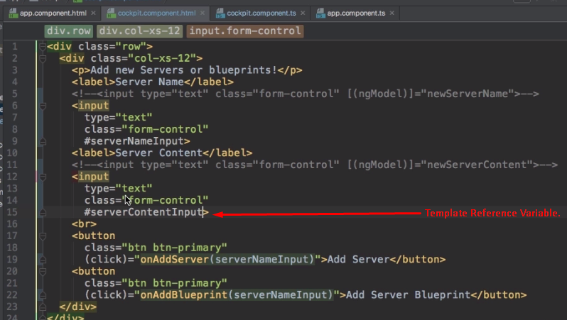
4. 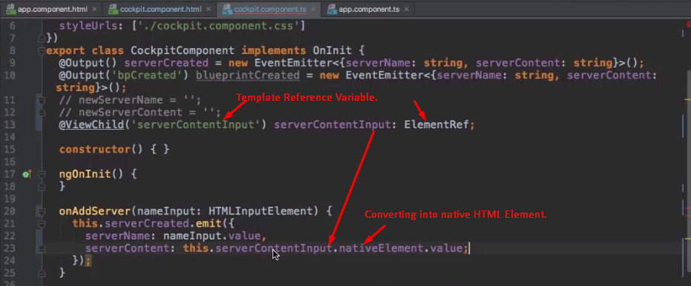
5. Strongly Recommended not to do the following.   
   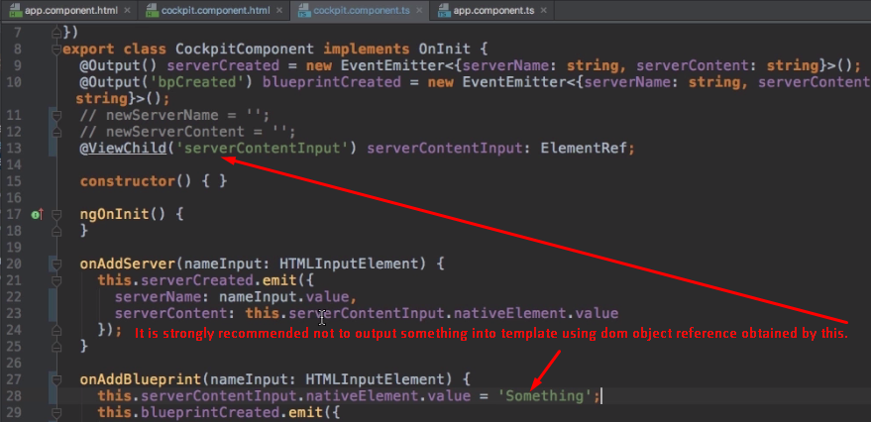
6. 